1. Steps how to create branches in azure git repo.

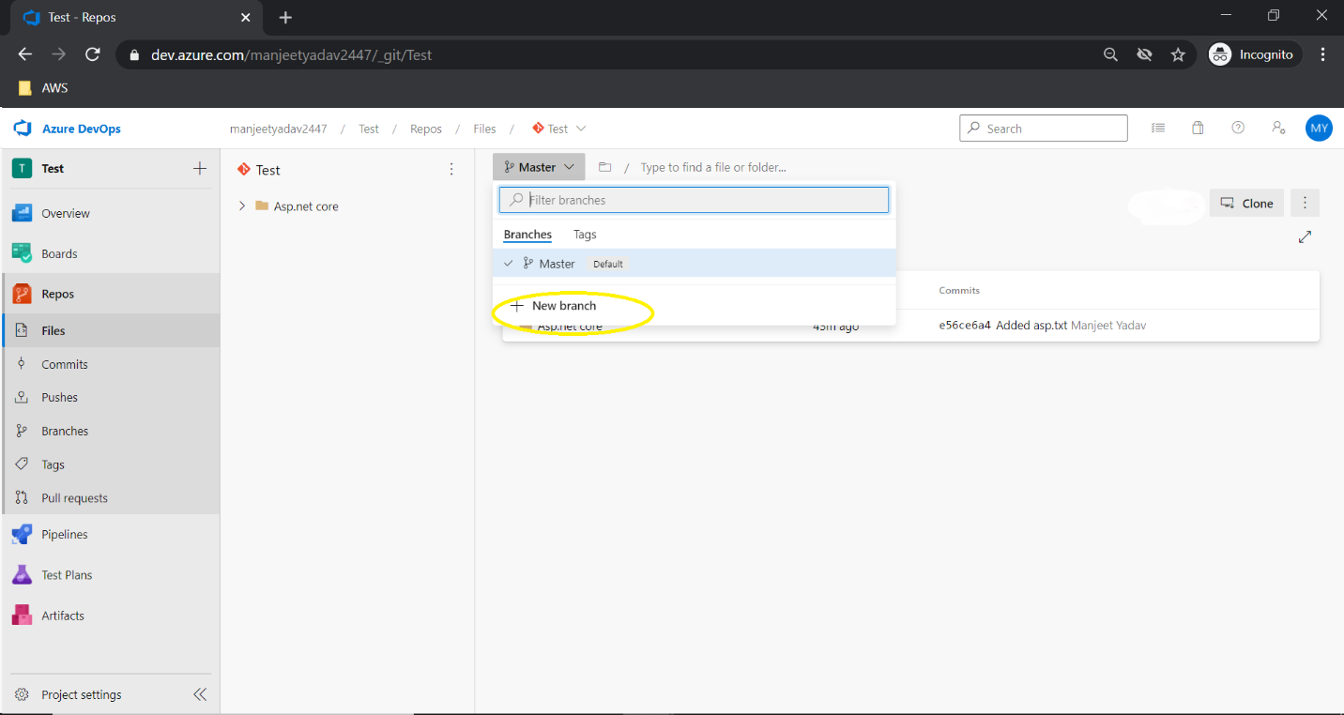

1. Please see the important note that I highlighted in red color(how to clone and push your code to azure git) –

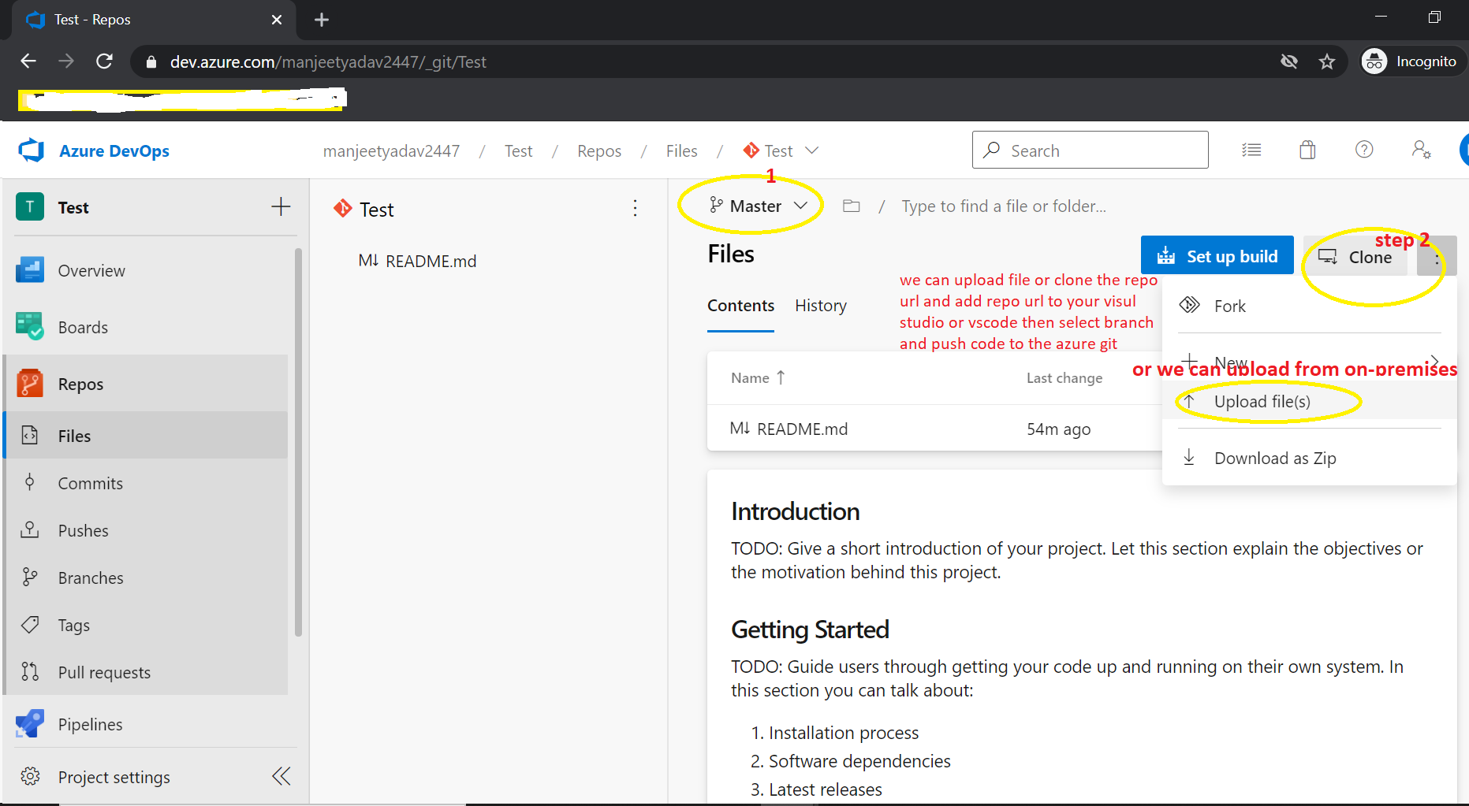

1. Steps for how to create build pipeline for dotnet Web App and Web Api project.

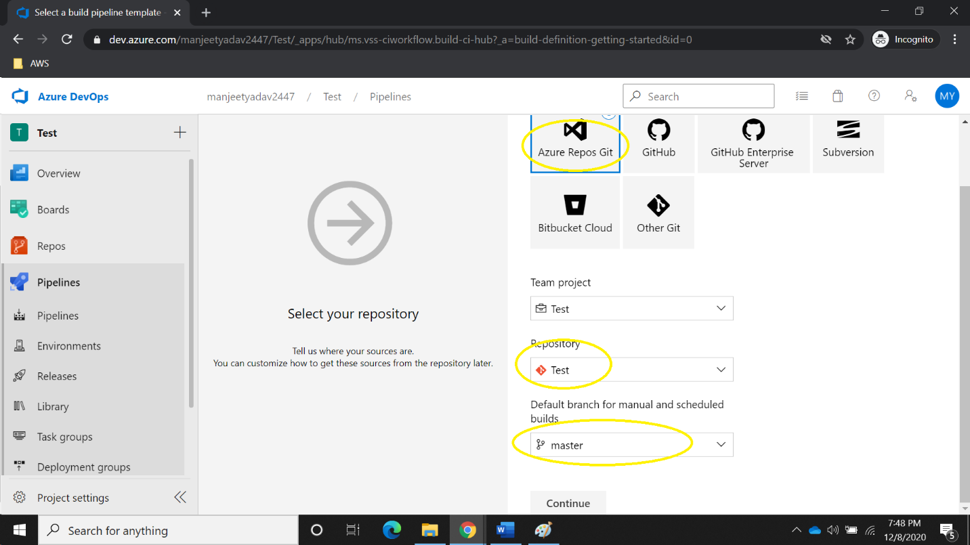

1. Steps for how to add task in the build pipeline.

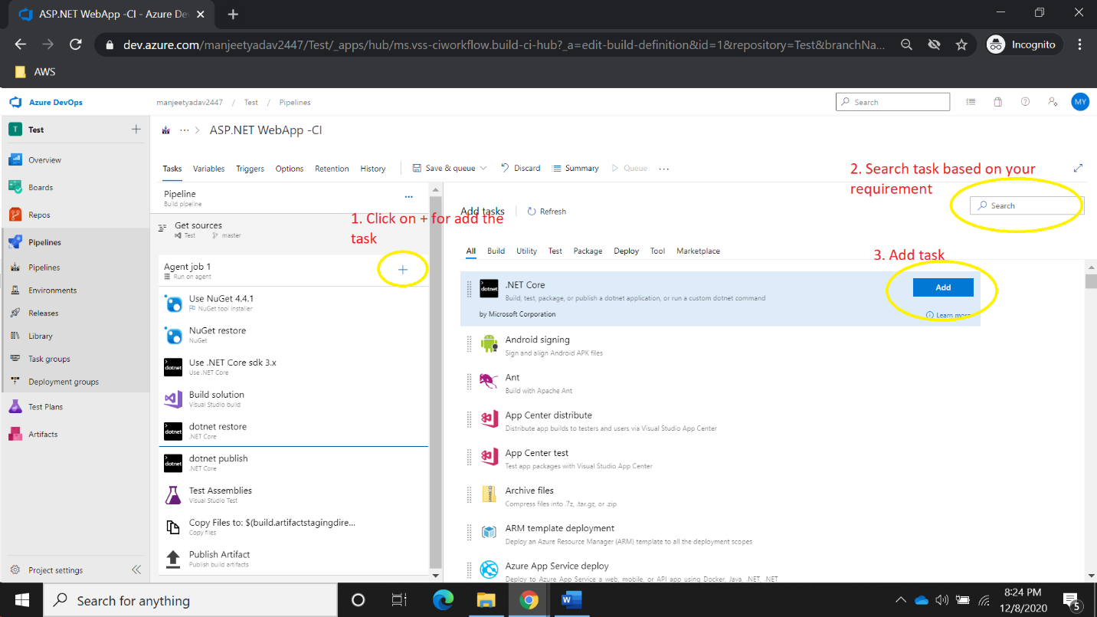

1. Steps for how to set build pipeline auto trigger when developer merge code into master branch.

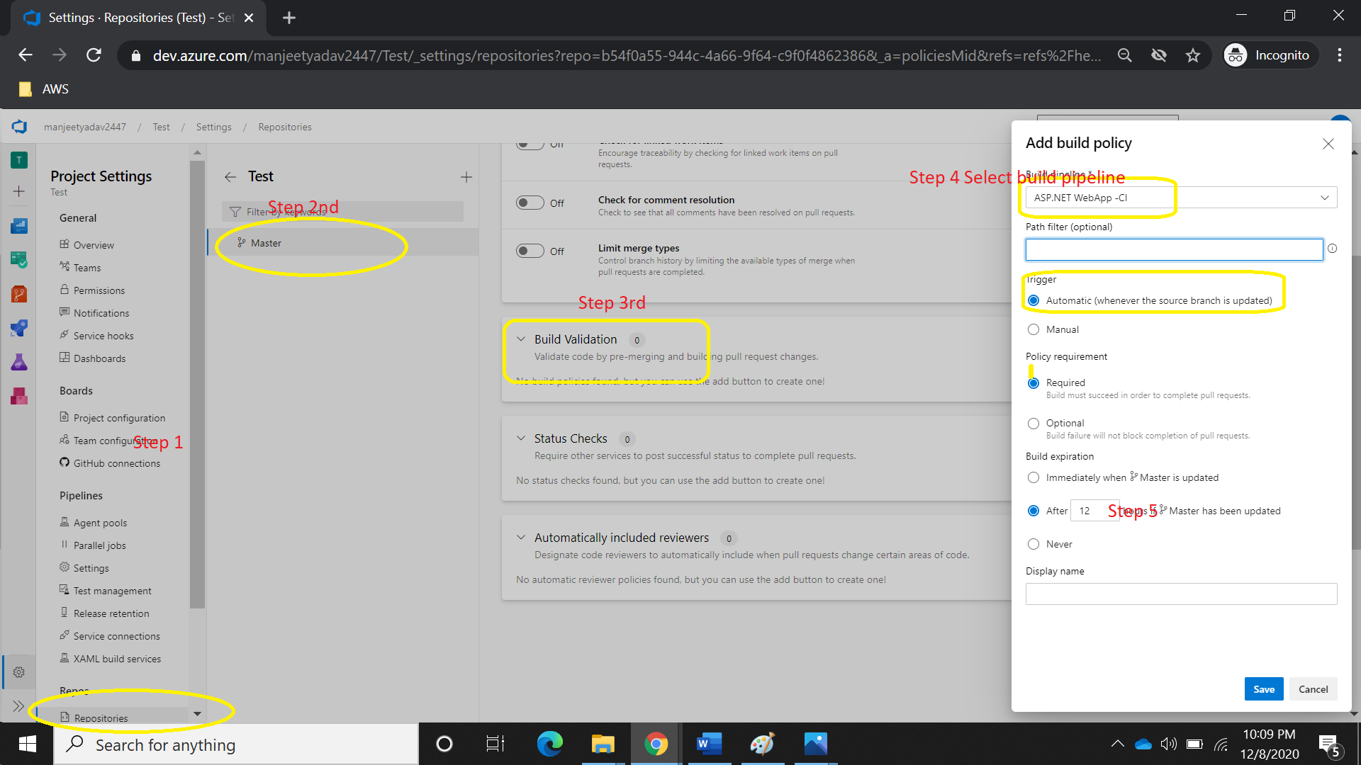

1. Second way once we create PR to merge code from Feature branch (developer branch) to master branch. Pleas find the below screenshot.

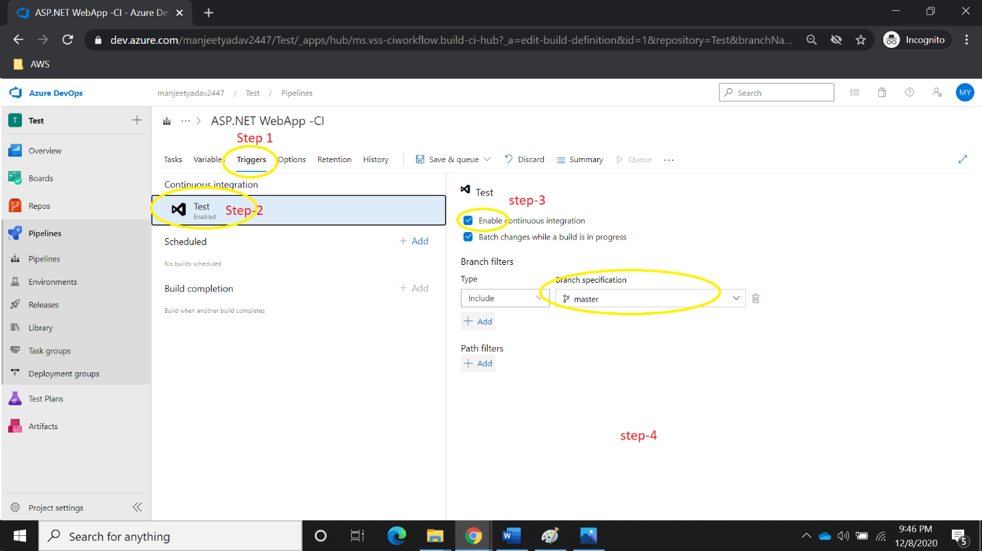

1. Please find the below Screenshot, I have explained about all the task. 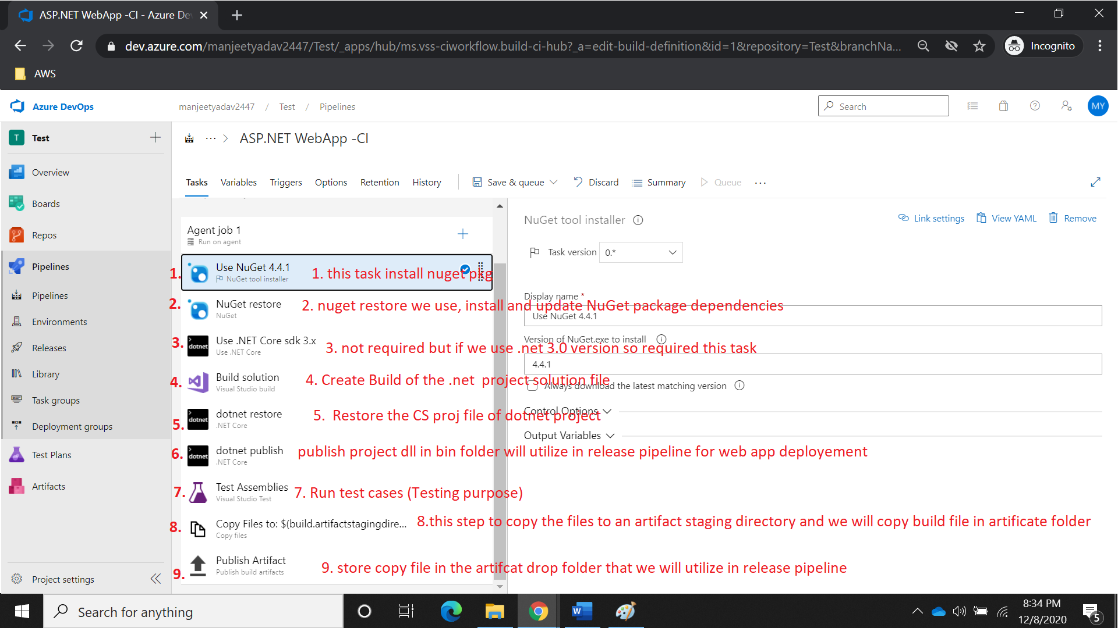
2. Adding above (7th ) step all the step one by one.

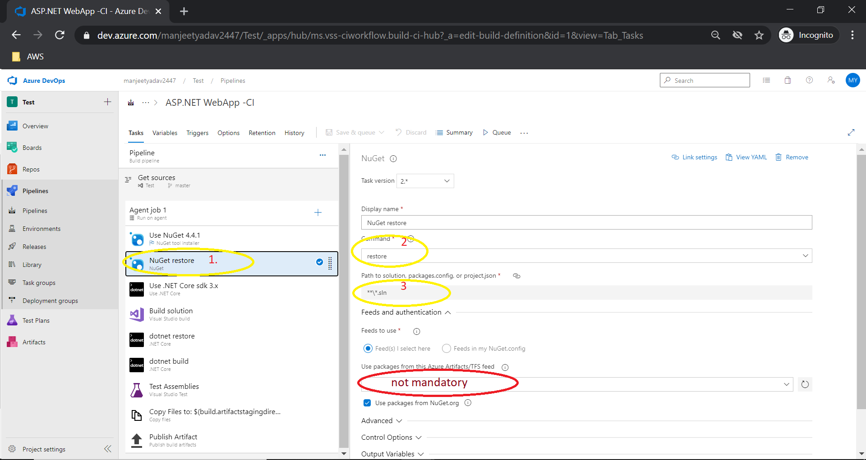

1. Steps for build task

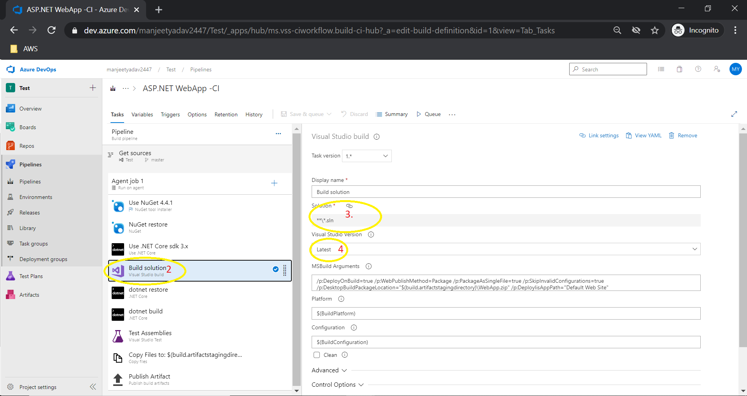

1. Mandatory Dotnet restore steps.

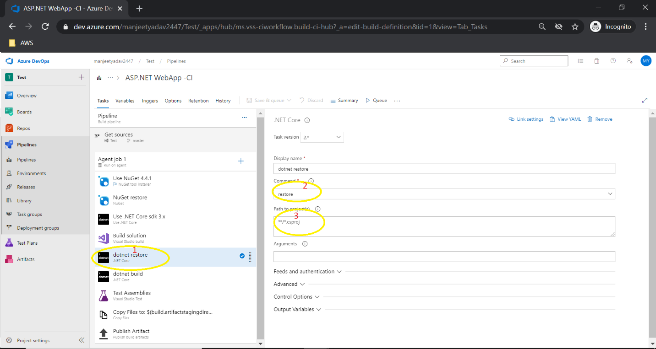

1. Steps for Publish dotnet code.

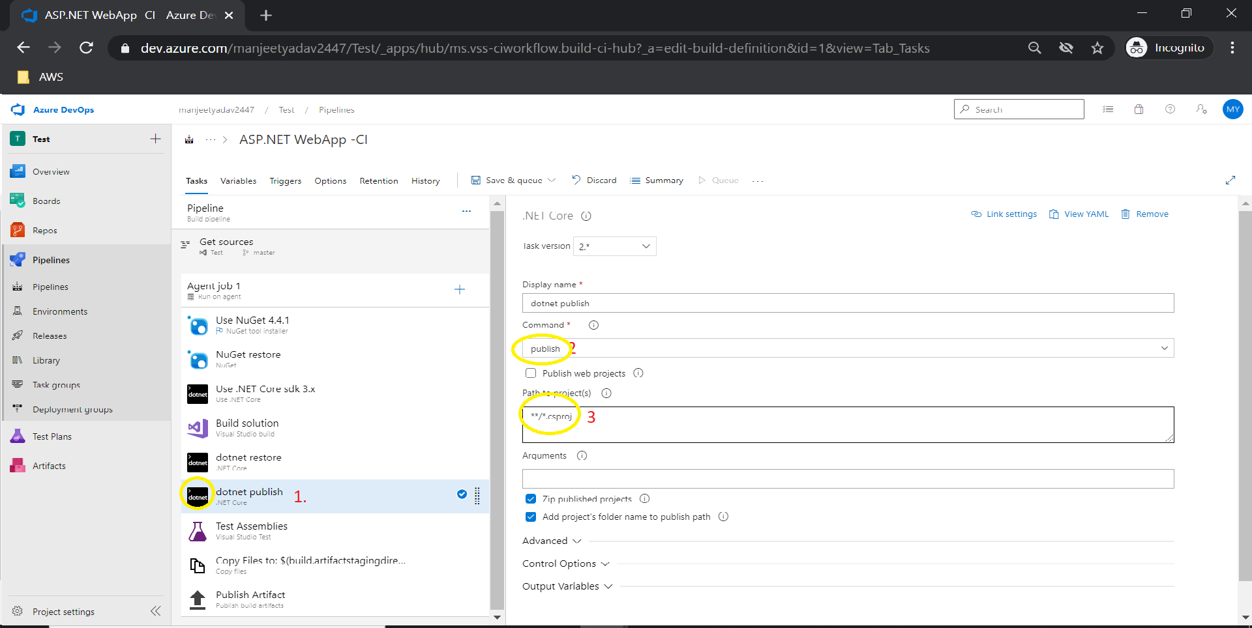

1. Run .net Test case.

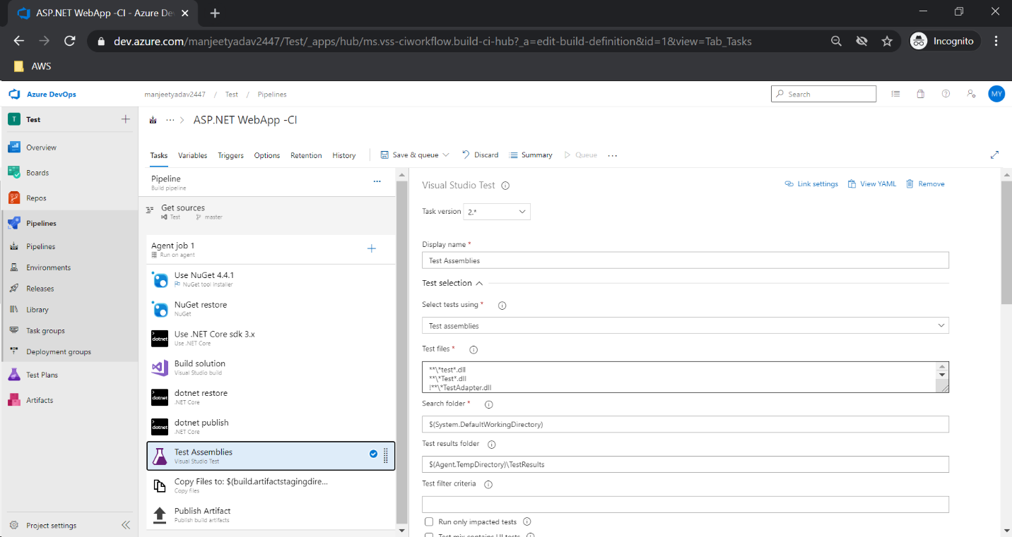

1. Copy dotnet build file.

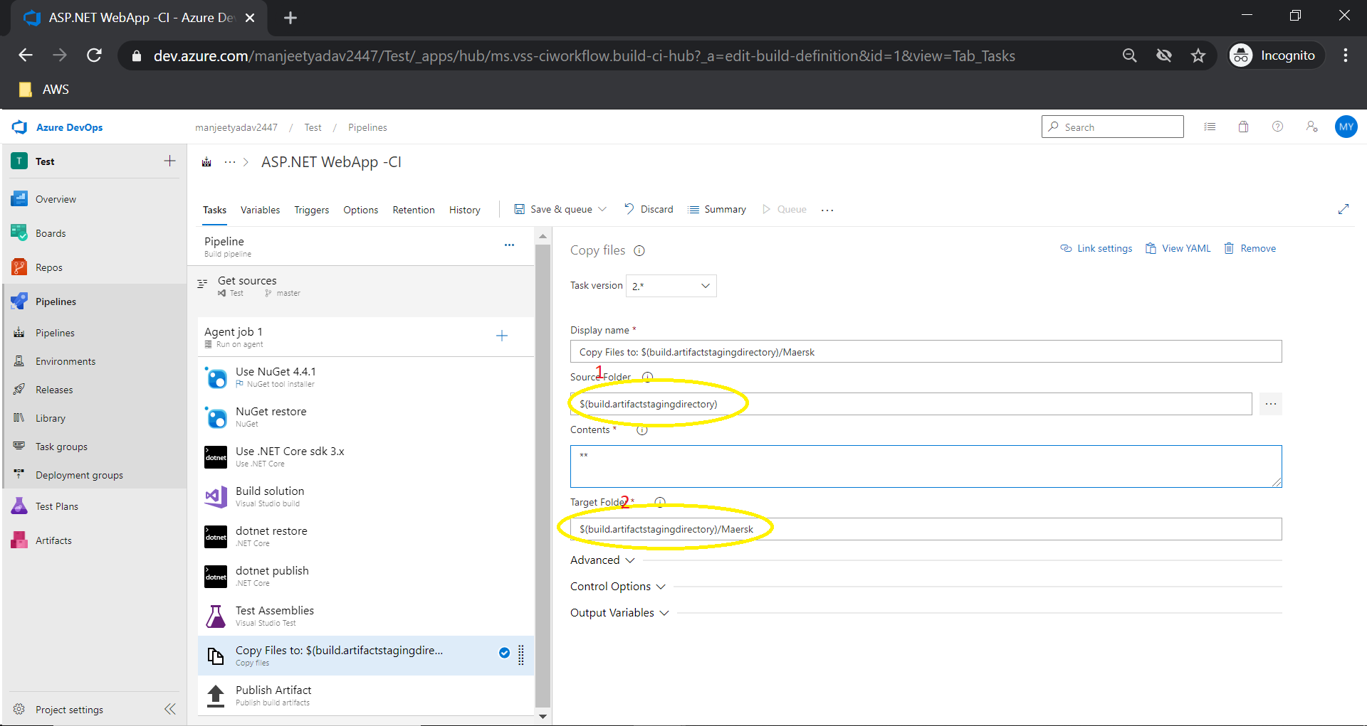

**STEP TO CREATE RELEASE PIPELINE**

1. Steps for Create release Pipeline.

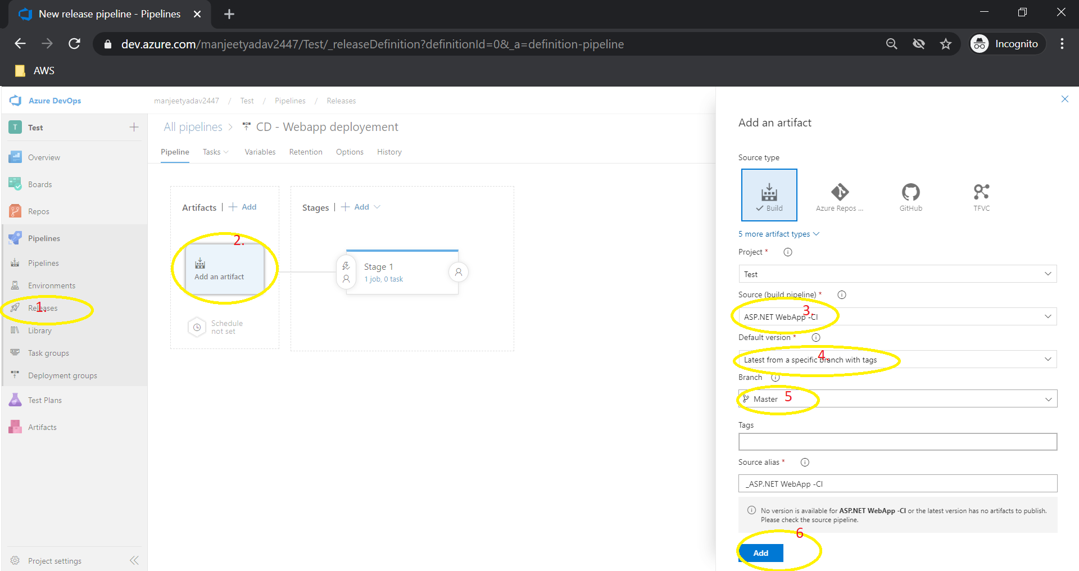

1. Set Staging for DEV, QA and PROD.

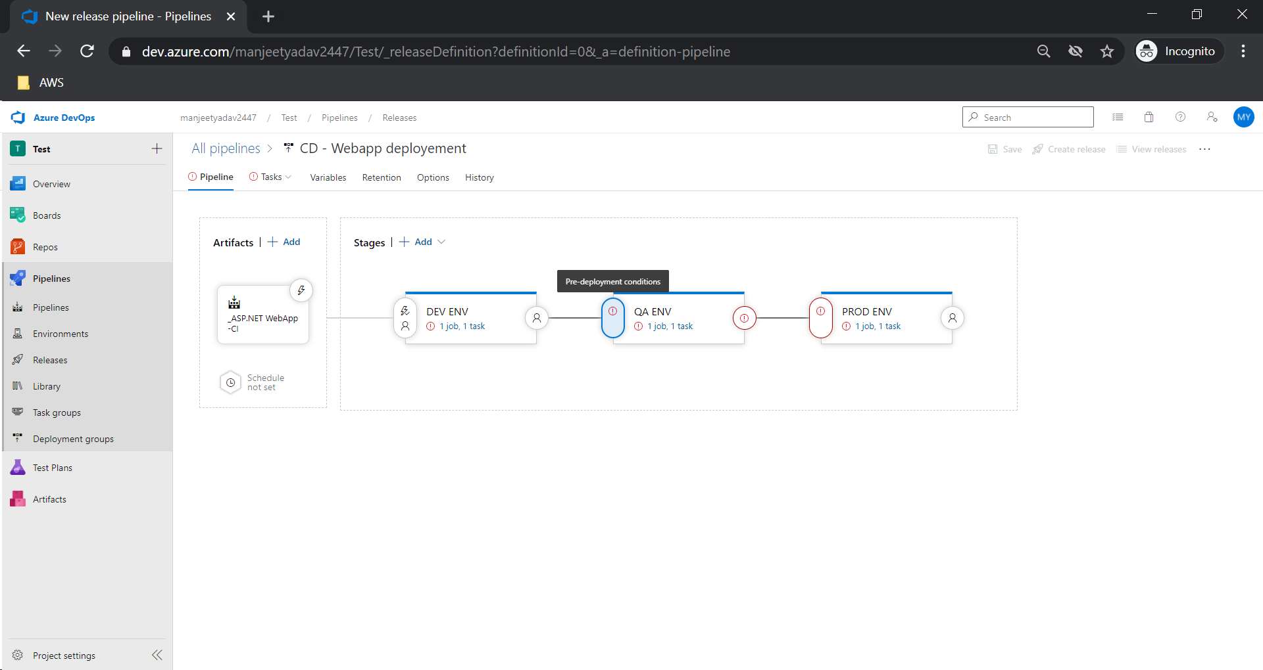

1. Add approver for higher environment like QA and PROD.

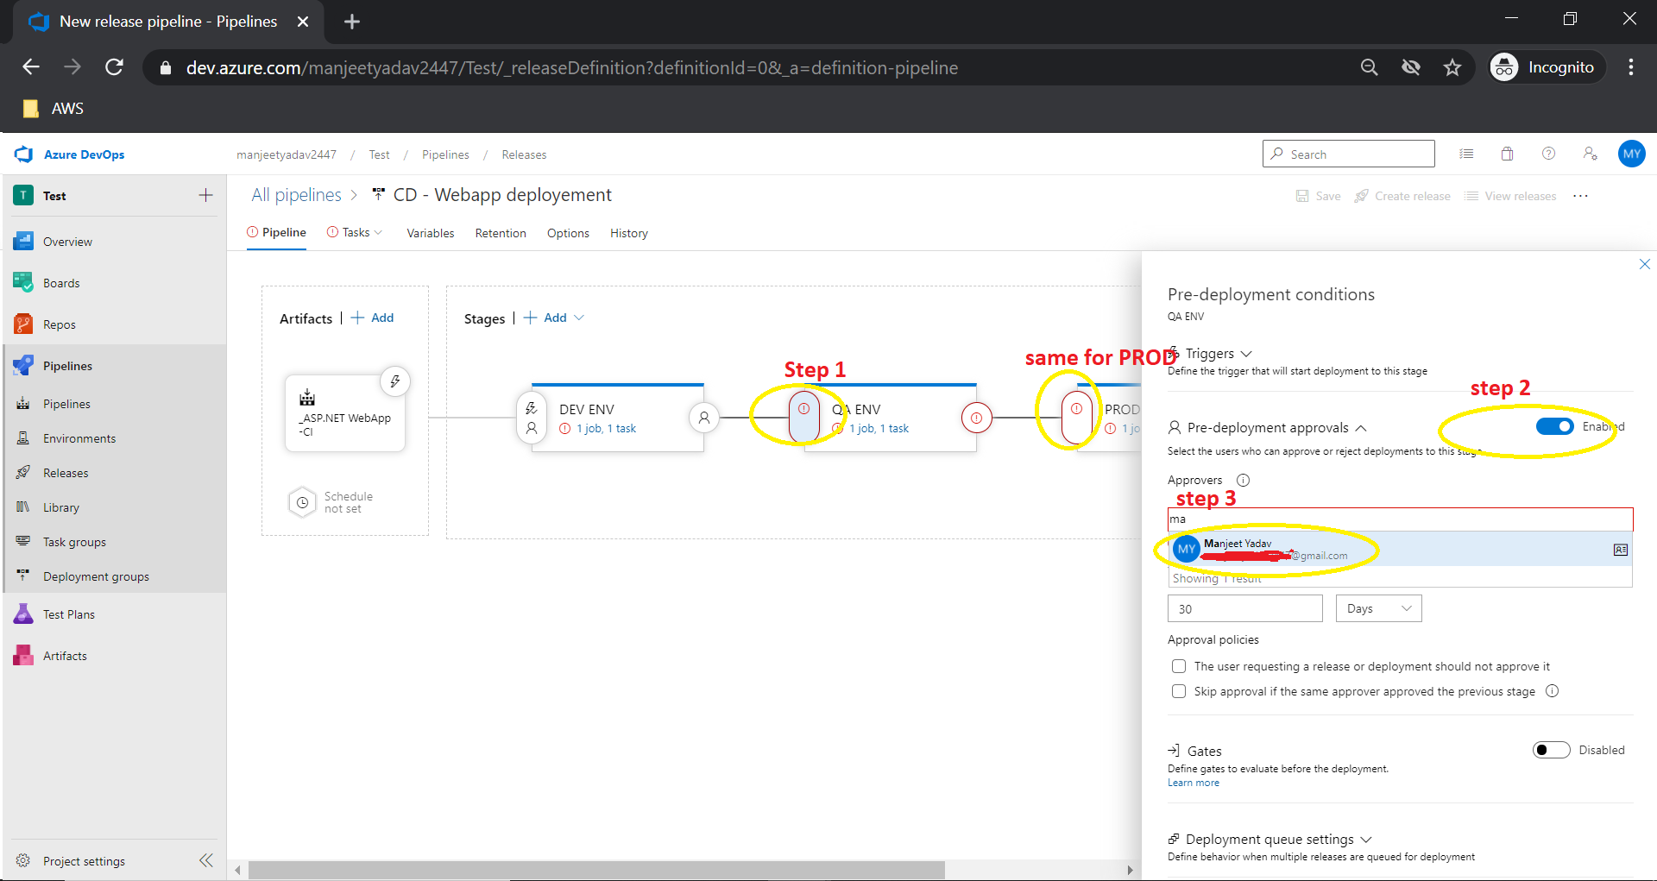

1. Step to add App service and setup and Same we can do for the webapi project also.

Here we need to create webapp in azure portal below are the steps.

1. Go to azure portal> click create resources > select webapp and click > create webapp.

